**LAB # 13**

**Task # 1: Write a Python program to implement the Loan Approval Prediction on the above-given scenario with the help of any best-suited classification algorithm.**

**Solution:**

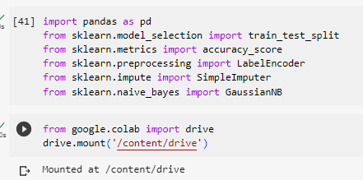

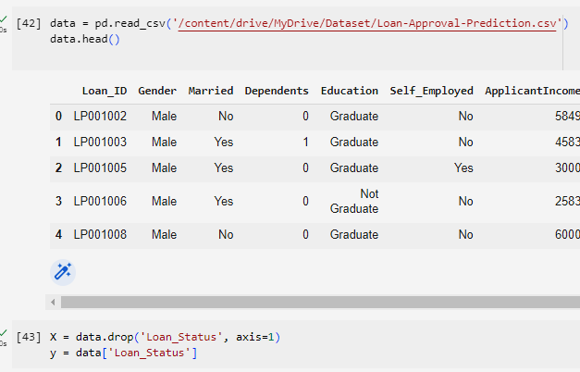

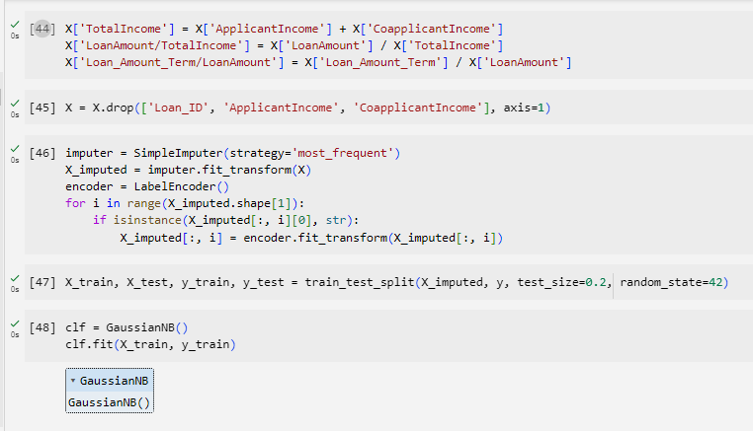

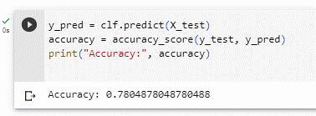

**Task # 2: Using Knime implement the above-given scenario to predict the loan approval.**

**Solution:**

